What is encapsulation?

Answer: Encapsulation means to hide data members. Data members means variables e.g. employee age, salary etc. by making them private so that nobody from outside the class can access it ***directly from outside the class***. It is also known as data hiding or **hiding implementation.** It also means to bind the variables and methods together.

In order to access these variables, one has to setter and getter methods. But logic inside the getter and setter methods to fetch or set the private variables is not visible or say is hidden to users.

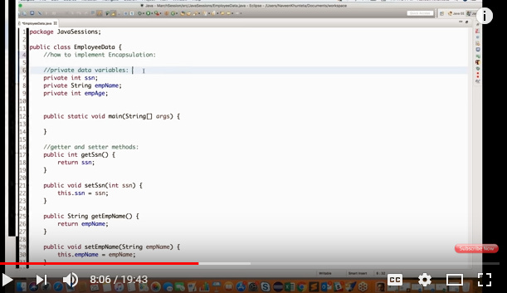

Difference between abstract class and interface?

Answer: Abstract class contains both abstract and non-abstract methods where interface contains only abstract methods.